Chapter 3, Problem 78.

Solve Prob. 3.20 using PSpice.

Chapter 3, Problem 20

For the circuit in Fig. 3.69, find V₁, V₂, and V₃ using nodal analysis.

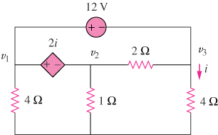

Figure 3.69
For Prob. 378.

